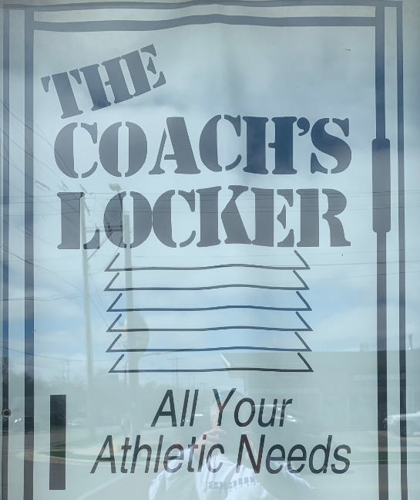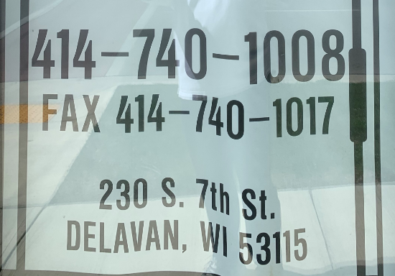

The Coaches Locker should be landscape and look something like this with a whole box around it.

We also need to change his phone number to be 262-740-1008

I will also send you the original JPG that is portrait mode.